THIS IS A DRILL!!!

SHORELINE RESPONSE AND SCAT PLAN

SHORELINE TREATMENT METHODS, RECOMMENDATIONS, ENDPOINTS AND INSPECTIONS

Draft

31 November 2111

_______________________________________ __________
Federal On-Scene Coordinator (FOSC) Date

_______________________________________ __________
State On-Scene Coordinator (FOSC) Date

_______________________________________ __________
Responsible Party Incident Commander (RPIC) Date

cc: Environmental Unit Leader
Planning Section Chief
Operations Section Chief
Operations Section, Shoreline Cleanup Supervisor
Operations Section Chief
National Oceanographic and Atmospheric Administration, SSC
U.S. Environmental Protection Agency
U.S. Department of Interior, U.S. Fish and Wildlife Service
State Historic Preservation Officer
State Agencies
Table of Contents

1 INTRODUCTION 3
2 OBJECTIVES 3
3 FIELD SURVEY METHODS 3
4 SCAT DATABASE AND SHORELINE TREATMENT RECOMMENDATION (STR) FORM 4
5 PARTICIPATION 5
6 TEAM ASSIGNMENTS 5
7 HISTORICAL / CULTURAL RESOURCES PROGRAM 5
8 SHORELINE TREATMENT AND INSPECTION PROCESS 6
9 ACRONYMS 10
Appendix A SCAT Shoreline Oiling Summary Form 11
Appendix B Shoreline Treatment Recommendation (STR) Form 13
Appendix C Post-Operation Inspection Survey Team (PIST) Memo and Segment Inspection Report (SIR) Form 15
Appendix D Methods and Endpoints 18
Appendix E Historic At-Risk Properties (HARP) 24
Appendix F Oil Thickness Definitions 25

INTRODUCTION

This document has been prepared to describe:

- The Shoreline Cleanup Assessment Technique (SCAT) program;
- The treatment recommendation decision process;
- The transition from Phase 1 (removal of heavy oil) to Phase 2 (cleanup to lowest practicable level) and from Phase 2 to 3 (monitoring and maintenance);
- The Phase 3 cleanup endpoints; and
- The eventual inspection process and cleanup endpoints for Phase 4 (final inspection and sign-off).

This document was prepared by a multi-agency Technical Working Group (TWG) within the Environmental Unit (EU) of the Planning Section of the Incident Command for the drill. The members included representatives from ………………………. In addition, comments from federal, state, county and city stakeholders have been incorporated, as appropriate.

OBJECTIVES

The objectives for this document are to describe the SCAT process (field survey methods, documentation, participation, team assignments, historical/cultural resource considerations), the four operational phases of response and to provide appropriate information for decisions regarding shoreline treatment, cleanup operations and tactics, and cleanup endpoints.

FIELD SURVEY METHODS

The SCAT process is a flexible approach and the assessment activities are designed to match the individual spill conditions. However, there is a set of basic principles that govern a SCAT survey:

- A systematic assessment of all shorelines in the Affected Area
- A division of the coast into geographic units or “segments”
- The use of a standard set of terms and definitions for documentation
- A team of personnel that represents the interests of the designated leading federal and state agencies, the responsible party, and representatives of applicable land ownership, management, or use interests.

Typically, the SCAT teams survey the shorelines of the Affected Area on foot, often supported by boats, and complete forms and sketches for oil zones within each segment, as necessary. For tidal flats and wetlands/marshes, surveys can generally be conducted along the fringes to avoid further disturbing these habitats and/or to avoid driving any oil deeper into the sediments by trampling. A standard Shoreline Oiling Summary (SOS) form has been developed for documentation (Appendix A). The terms and definitions used to document the oiling conditions follow those presented in the NOAA and Environment Canada SCAT manuals.

Surveys will be restricted to a period two hours on each side of the low tide slack.

The SCAT teams are expected to provide recommendations or advice regarding appropriate treatment methods and tactics by segment using the Shoreline Treatment Recommendation (STR) form (Appendix B) and also to identify ecological, historical/cultural resource, and safety constraints or limitations on the application of treatment techniques, so that the operational activities do not result in additional damage to the shore zone. The SCAT teams monitor and document segment cleanup status with a Post-Operations Inspection Survey Team (PIST) inspection and memo (Appendix C). The final inspection is documented with a Shoreline Inspection Report (SIR) (Appendix C).

At some time during the SCAT program for this release the entire accessible coastal area between ………. and…………. will be surveyed.

SCAT DATABASE AND SHORELINE TREATMENT RECOMMENDATION (STR) FORM

The completed field documents (forms and sketches) are inspected at the Command Post for Quality Assurance / Quality Control (QA/QC) the same day to ensure that any necessary revisions are made prior to the surveys of the next day. All data and photos are promptly entered into the existing SCAT database.

If the oiling conditions in a segment do not meet the cleanup endpoints(s) as defined in Appendix D for the shoreline type(s) present in that segment, then a STR Form is prepared (Appendix B). This form typically contains recommendations for cleanup activities that would be appropriate in that segment.

If the segment has No Observed Oil (NOO) or meets the cleanup endpoints, and therefore No Further Treatment (NFT) is required, then an STR Form is not prepared.

The STR Form is reviewed and approved by the Historic Properties Specialist (HPS) for input on historical/cultural resources that might be at risk from the oil or the cleanup operations (see Appendix E), and the Environmental Unit Leader (EUL) for environmental risk and environmental priority assignment. Once approved by the EUL and the HPS, the STR Form is forwarded to Operations via the EUL.

PARTICIPATION

Each SCAT team has, at a minimum:
- An experienced shoreline oil observer responsible for completing the oiling documentation (Oil Geomorphologist, usually referred to as the “OG”)
- A responsible party representative
- A federal representative, and
- A state representative (typically a natural resource trustee experienced in oil impacts to natural communities).

One person may be filling two of these roles.

Furthermore, the team may also have, depending on the segment to be surveyed:
- A land owner, land manager, or a trustee agency representative, and/or
- A local community representative.

Again, one person may fill more than one role.

TEAM ASSIGNMENTS

Traditionally the OG is the team leader and assigns the following tasks:

- Completion of the SOS Form
- Completion of the STR Form, Memo or SIR Form
- Preparation of the sketch(es) of the segment if oil is observed – no sketch is required if no oil is observed in the segment
- Recording of GPS boundaries of the segment endpoints and other specific features
- Digital photographs and logging date/time/location – no photos are required if no oil is observed in the segment, but one alongshore general photograph typically would be taken at the high water level to record the shore-zone character
- Digging of pits/trenches if subsurface oil is suspected based on beach characteristics

Final conclusions of these tasks are reached by consensus of the interdisciplinary SCAT team.

HISTORICAL / CULTURAL RESOURCES PROGRAM

During SCAT surveys, where necessary, confidential historical/cultural resource data are collected so that an appropriate cultural resource constraint for response operations can be applied to the applicable segment. After each segment has been surveyed, the Historic Properties Specialist (HPS) proposes constraints for approval in consultation with land owners, other affected parties, and the State Historic Preservation Office (SHPO) (see Appendix E). To protect site confidentiality, specifically site location data, the cultural resource constraints are not made publicly available.

SHORELINE TREATMENT AND INSPECTION PROCESS

All spills have a point at which active cleanup and removal (the emergency response phase) gives way to the natural degradation of the oil (post emergency activities). In the case of this spill of a heavy fuel oil, this termination point, or cleanup endpoint, is qualitative and is primarily based on visual, tactile or olfactory observations and does not require extensive chemical analyses. Cleanup endpoints should be developed as a consensual process, based on best professional judgment, and field verified by representatives of the Unified Command, in cooperation with the appropriate land owner/manager and other stakeholders. The Unified Command has final decision-making authority. The question of ‘how clean is clean’ is complex due to the many variables that need to be taken into consideration when developing cleanup endpoints (e.g., oil type, cleanup technologies, habitat and species present, worker safety, and logistical issues).

Generally speaking, emergency response cleanup may normally be terminated when the following conditions occur:
- The agreed upon cleanup endpoints have been reached; and
- Best achievable protection has been met and best achievable technologies have been used; and
- The objectives in the spill specific Incident Action Plan (IAP) have been met; or
- The agreed upon qualitative cleanup endpoints have been reached but the project needs to be handed-off to another agency that may have additional endpoint(s) defined by regulation or policy; or
- No further cleanup is practicable because:
  - The area/habitat is inaccessible (e.g., an exposed rocky cliff); or
  - Remedial actions are no longer effective; or
  - The environmental damage caused by the cleanup efforts is greater than the damage caused by leaving the remaining or residual oil in place; or
  - The cost of cleanup operations significantly outweighs the environmental or economic benefits of continued cleanup [per the Regional Response Team Regional Contingency Plan (RCP; USEPA/USCG, 2005) section 1002.05].

In all cases, the endpoint is reached when worker safety would be compromised or the remaining oil presents less of a risk to the community or the resources than the treatment methods available.

In this incident, the shoreline treatment operation has been divided into four phases, as outlined in the attached flow chart below (Figure 1):

Phase 1, which has been completed, involves the safe removal of the heavy oil concentrations from the water and shorelines.

The transition from Phase 1 to Phase 2 is based on an Operations decision that removal of heavy oil concentrations on water and shorelines has been completed.

Phase 2 is the phase in which recoverable oil is removed by Operations to the Lowest Practicable Level of Contamination, based on recommendations developed by the SCAT teams and recorded on the Shoreline Treatment Recommendation (STR) form (Appendix B).

For the Phase 2 to Phase 3 transition, Operations will identify the segments to be inspected. The SCAT/Post Operations Monitoring (PIST) team will conduct their inspection at least 48-hours after the EU is notified by Operations that a segment is ready for inspection. SCAT/ teams can include trustee and/or other resource agencies as appropriate. During their inspection, the SCAT/PIST teams will determine the need for further treatment. If they determine that no further treatment is required, i.e., that the lowest practicable level of contamination has been met, based on best professional judgment, they will document that decision and the character of any remaining oil in the Memo (Appendix C). If they determine that more treatment is required, they will complete a new STR Form to be submitted to Operations.

The key features of the Phase 2 and 3 inspection program are:

- In the Phase 2 to Phase 3 transition teams will inspect all treated segments at least once prior to December 22, 2XXX to ensure that they continue to meet lowest practicable level of contamination. This survey will generate signed forms and possibly STR Forms.

- In Phase 3 all segments within the Affected Area will be re-surveyed after December 27, 2XXX to determine if they meet the cleanup endpoints. This includes segments initially identified as NOO or NFT in the initial survey and will generate a signed SIR for each segment in the Affected Area.

- Also in Phase 3, a monitoring schedule for segments that have shown a susceptibility to re-oiling during this incident will be developed by the EU.

Phase 3, post emergency response, is the maintenance and monitoring phase during which (1) Operations cleanup crews are on standby to react and be deployed as necessary and (2) the segments that had been treated are monitored by the Teams.

If the Team determines that a segment requires further treatment, they will notify Operations and provide specifics on what actions would be required via a new STR. If they do not recommend further treatment, they document the visit and oiling conditions in a Memo.

In the Phase 3 survey of the affected area after December 27, 2XXX, if the team determines that no oil is present in the segment or that the cleanup has met the cleanup endpoints defined in Appendix D, then the members of the team who represent the UC and the trustee agencies, as appropriate, complete a Shoreline Inspection Report (SIR) form, documenting that either there is No Observed Oil (NOO) or that no further treatment (NFT) is appropriate because natural weathering is considered to be the most appropriate remaining cleanup strategy. If the PIST team determines that more treatment is required, the specific work that is required to pass Phase 4 inspection is identified on the SIR Form. A new SOS form will be completed to accompany the SIR Form. The signed SIR Form is forwarded to the Unified Command for approval.

Determination that cleanup endpoints have been reached does not indicate that the segment is necessarily recovered or restored under the definition of the NRDA process. Furthermore, if team members are not unanimous regarding whether or not the cleanup endpoints are met, then a sheet listing the reasons for disagreement is attached to the SIR and forwarded to the Unified Command for resolution.

The expectation is that Phase 3 will be completed by early January 2008 (60 days post spill). However, local cleanup teams will respond to notification of oil by agencies and the public until the start of Phase 4.

Phase 4, final emergency response sign-off, represents the multi-agency and land manager inspection process and will be based on the concept of NOO or NFT. Cleanup endpoints for Phase 4 are considered to be the same as for Phase 3 (Appendix D). Phase 4 will involve a shoreline inspection of all segments for which drill oil has been documented and will be completed at a time to be determined by the Unified Command. The expectation is that this will take place in late Spring/early Summer 2XXX. The inspection will be carried out by one or more SCAT teams with participation by the trustee agencies, land owner/manager and/or designated stakeholders. Typically, this inspection is the final “sign-off” that signals that sufficient response treatment has been completed for a segment.

Each team will complete a Phase 4 SIR Form. If the shoreline condition is determined by consensus to be NOO, NFT, or that the cleanup endpoints have been met, then a recommendation will be made to the Unified Command that no further activities are required in that segment and that the segment should be “signed-off”. The SIR Form is signed by each of the three Unified Command representatives. Any land owners/manager comments on the SIR will be reviewed by the Unified Command prior to the sign-off.

Segment sign-off is based on field observations and best available data that exists on the date the sign-off is executed. Segment sign-off does not preclude a lead or trustee agency to require the responsible party to conduct additional clean up activities pursuant to any applicable laws, or in the event that additional contamination is discovered. Segment sign-off also does not preclude additional actions required by other agencies with jurisdiction (e.g., long-term maintenance and monitoring may be necessary).

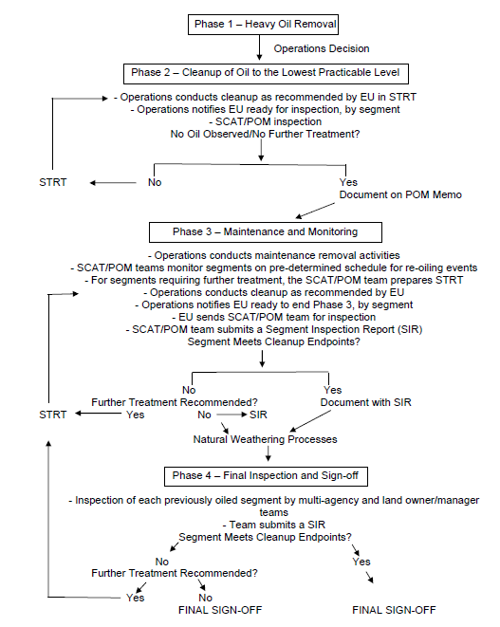

Figure 1. Four-Phase Shoreline Treatment and Inspection Process

ACRONYMS

EUL Environmental Unit Leader
NEB Net Environmental Benefit
QA/QC Quality Assurance/Quality Control
SCAT Shoreline Cleanup Assessment Team
SOS Shoreline Oiling Survey
STR Shoreline Treatment Recommendation

Appendix A SCAT Shoreline Oiling Summary Form

This form is completed by the SCAT team.

CONFIRM FORMS – see http://shorelinescat.com/Forms%20Oiling.html

The standard form is the Shoreline Oiling Summary (SOS) form.

- If no surface or subsurface oil is observed in a segment, then (1) in Box 6 and Box 7, the “NO” box in OIL CHARACTER is checked, and (2) there is no need to complete Box 5 (“Operational Features”) and Box 8.
- Where oil is observed in a segment that does not meet the Cleanup Endpoints (Appendix D), a SHORELINE TREATMENT RECOMMENDATION (STR) form (Appendix B) is completed by the SCAT team.

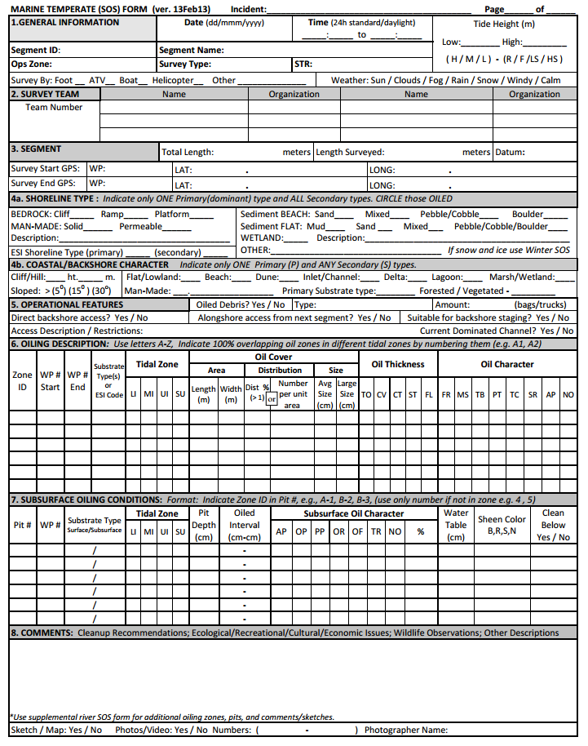

Appendix B Shoreline Treatment Recommendation (STR) Form

If the SCAT team determines that the segment has No Observed Oil (NOO) or that the oiling conditions met the cleanup endpoints in Appendix D, and therefore No Further Treatment (NFT) is required, then a STR Form is not prepared.

If the SCAT team determines that the oiling conditions in a segment do not meet the cleanup endpoint(s) for the shoreline type(s) present in that segment, as defined in Appendix D, then the SCAT team prepares a STR form. This form contains recommendations for cleanup activities that would be appropriate in that segment. The STR Form is completed by the SCAT team and forwarded to the SCAT Field Coordinator/Data Entry Manager in the Command Post.

If SCAT team members are not unanimous regarding treatment recommendations or the constraints, then a sheet listing the reasons for disagreement is attached to the STR Form and forwarded to the UC for resolution.

The STR Form is routed by the SCAT Field Coordinator/Data Entry Manager for review initially and then is reviewed and approved by:
- the Historic Properties Specialist (HPS) and
- the Environmental Unit Leader (EUL) for environmental risk and environmental priority assignment.

Once approved, the form is forwarded to Operations via the EUL.

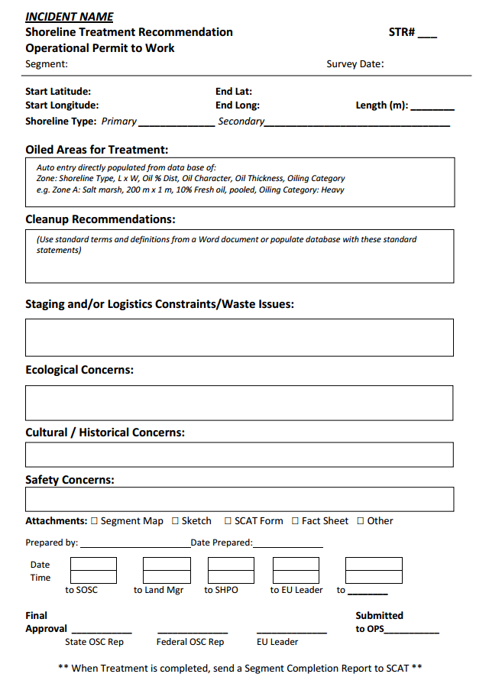

Appendix C Post-Operation Inspection Survey Team (PIST) Memo and Segment Inspection Report (SIR) Form

During Phase 3, the SCAT Post-Operations Inspection Survey Team (PIST) teams conduct surveys as described in Section 8. If cleanup is recommended, they complete a STR Form and submit it to Operations. If no cleanup is recommended, i.e., natural weathering to continue, they document the visit and oiling observations on a PIST Memo (attached)

At the end of Phase 3, the SCAT/ teams use the criteria in Appendix D to make the following determinations:

- If the SCAT/PIST team determines that NO OBSERVED OIL (NOO) is present in the segment, or that the cleanup has met the cleanup endpoints and that NO FURTHER TREATMENT (NFT) is required then the members of the interagency SCAT PIST Team who represent the UC sign the Segment Inspection Report (SIR) form and forward this recommendation to the UC for approval.

- If a segment fails to meet the cleanup endpoints, by unanimous agreement among the UC representatives, the SCAT/PIST Team indicates on the STR form where work is required and what should be done to pass inspection and send the form to the SCAT Field Coordinator /Data Manager who forwards this to Operations via the EUL.

If SCAT/PIST team members are not unanimous regarding whether or not the cleanup endpoints are met, then a sheet listing the reasons for disagreement is attached to the SIR Form and forwarded to the UC for resolution.

The SIR Form will be used by the SCAT/Land Owner/Manager inspection team as part of the Phase 4 inspection of the segments that were oiled.

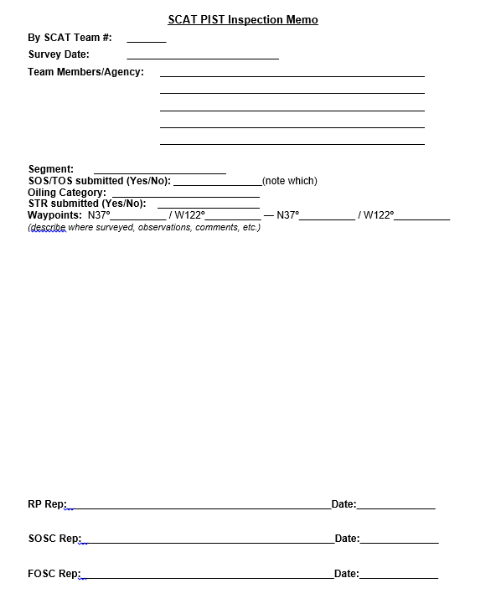

Appendix D Methods and Endpoints

Introduction

In this section, cleanup methods and endpoints are described for each shoreline habitat that was oiled as a result of the drill. The habitat-specific endpoints are derived from the following general guidelines (for non-historical/cultural properties):

- No oiled accessible debris
- No surface oil on hard substrates (e.g., seawalls, pilings, riprap) greater than Stain (visible oil but cannot be scraped off with a fingernail) or Coat (less than 1/16 inch) at > 20% distribution in the oiled band; in high public use or visibility areas, the endpoint is no greater than Coat at 10% distribution in the oiled band
- Does not rub off on contact
- In areas with data on background rates of tar ball deposition (e.g., NMS beach survey programs), no tar balls greater than background for surveys over a two month period;
- In areas without data on background rates of tar ball deposition, no tar balls > 1cm in size and at a frequency less than 1 to 5 per 100 linear m of shoreline, depending on degree of use or sensitivity
- No petrogenic (petroleum-derived) sheens, that may affect sensitive resources

In every instance, human health and safety is of primary importance and is not to be jeopardized for any treatment operations. The final determination as to the safety of a treatment operation is made by the Unified Command and the Operations Supervisors. In areas that are inaccessible because of these worker safety concerns, it is realized that some oil will remain for removal by natural processes.

Segments containing listed species, historical/cultural resources, eelgrass beds may be considered individually on the STR and may have treatment methods and/or endpoints defined by the TAG specific to that location.

These cleanup endpoints apply only to oil residues and tar balls from drill.

Natural Rocky Intertidal Habitats – Headlands, Cliffs, Platforms, Large Boulders:

Methods to be used in areas where further treatment is recommended by the EU:
- Manual removal by scraping or wiping with sorbents; in sensitive areas (as identified by the EU), a biological monitor will be required to monitor operations
- Manual removal of oiled garbage and debris (do not conduct wholesale removal of unoiled natural debris)
- For areas that are inaccessible by cleanup crews, monitoring of the effectiveness of natural recovery will be conducted

Cleanup Endpoints:
- No accessible oiled debris
- No surface oil greater than Stain or Coat on solid surfaces >20% distribution
- No oil on surfaces that rubs off on contact
- In inaccessible areas where oil removal was not possible because of safety restrictions, the endpoint is no longer generates petrogenic sheens that can affect sensitive resources under any weather conditions

Manmade Structures – Pilings, Seawalls, Sheet-Pile, and Large Objects (Non-Porous or Low Porosity Objects) Excluding All Historic Properties:

Methods to be used in areas where further treatment is recommended by the EU:
- Manual removal of oiled garbage and debris (do not conduct wholesale removal of unoiled natural debris)
- Manual removal by scraping or wiping with sorbents
- Oiled surfaces may be washed with high pressure or high pressure, hot water (HPHW) flushing:
  - HPHW flushing should be conducted during appropriate tide stages to prevent damage to lower intertidal biota. Flushing can start when the rising tide covers the rockweed; flushing must stop when the falling tide begins to expose the rockweed. This tidal level is about +3-4 feet above MSL
  - Containment boom and sorbents will be deployed to contain and recover released oil
  - For application on single objects, sorbents can be placed around and below the object for oil recovery
  - Because of concerns about the ability to contain and recover released oil in exposed areas, HPHW flushing will only be used in relatively sheltered areas
- No hot water flushing will occur on NPS or NMS lands without their permission
- Use of Cytosol is allowed on segments as recommended by the EU and approved by the land owner/manager
- Deployment of sorbents to passively recover oil released by natural processes
- Digital photographs before and after treatment of seawalls with locational information (GPS coordinates; at a minimum, segment ID) to be submitted to the Historic Properties Specialist (refer to Appendix E for more information on historic properties at risk)

Cleanup Endpoints:
- No accessible oiled debris
- No surface oil greater than Stain or Coat on solid surfaces > 20% distribution
- In high public use or high public visibility areas, no surface oil greater than Stain or Coat > 10% distribution on solid surfaces
- In public access areas, no oil on surfaces that rubs off on contact
- In inaccessible areas where oil removal was not possible because of safety restrictions, the endpoint is no longer generates petrogenic sheens that can affect sensitive resources under any weather conditions

Sand, Mixed Sand and Gravel, and Gravel Beaches:

Methods to be used in areas where further treatment is recommended by the EU:
- Manual removal of oil and oiled sediment
- Manual removal of oiled garbage and debris (do not conduct wholesale removal of unoiled natural debris)
- Surf washing, which includes containment and recovery of released oil, where recommended by the EU

Cleanup Endpoints:
- No accessible oiled debris
- For monitored ocean beaches, including those that are snowy plover habitat, no surface oil in the form of tar balls above background for two consecutive monthly surveys and no visible subsurface oil
- No surface oil on sand or gravel that rubs off on contact
- No surface oil on sand or gravel greater than Stain or Coat > 10% distribution
- For bay beaches, no surface oil or subsurface oil in the form of tar balls > 1cm at a frequency greater than 5 per 100 linear m of shoreline
- For high public use bay beaches, no surface oil in the form of tar balls > 1cm at a frequency of 1 per 100 linear m of shoreline and no visible subsurface oil

Manmade Structures – Rip Rap (High Porosity Substrates) Excluding All Historic Properties:
Methods to be used in areas where further treatment is recommended by the EU:
- Manual removal by scraping or wiping with sorbents
- Manual removal by wiping accessible oil in crevices with sorbents
- Manual removal of oiled garbage and small debris (do not conduct wholesale removal of unoiled natural debris)
- Oil on large objects that cannot be manually removed will be scraped or flushed
- During manual removal activities, workers should avoid trampling areas with attached biota (mussels, seaweeds)
- Oiled surfaces may be washed with high pressure or high pressure, hot water (HPHW) flushing:
  - HPHW flushing should be conducted during appropriate tide stages to prevent damage to lower intertidal biota. Flushing can start when the rising tide covers the rockweed; flushing must stop when the falling tide begins to expose the rockweed. This tidal level is about +3-4 feet above MSL
  - Containment boom and sorbents will be deployed to contain and recover released oil
  - For application on single objects, sorbents can be placed around and below the object for oil recovery
  - Because of concerns about the ability to contain and recover released oil in exposed areas, HPHW flushing will only be used in relatively sheltered areas
- No hot water flushing will occur on NPS or NMS lands without their permission
- Use of Cytosol is allowed on segments as recommended by the EU and approved by the land manager
- Deployment of sorbents to passively recover oil released by natural processes alone may be used in inaccessible areas

Cleanup Endpoints:
- No accessible oiled debris
- No surface oil greater than Stain or Coat > 20 % distribution
- No oil on surfaces that rubs off on contact
- In high public use or high visibility areas, no surface oil greater than Stain or Coat >10% distribution on solid surfaces
- In inaccessible areas where oil removal was not possible because of safety restrictions, the cleanup endpoint is: no longer generates petrogenic sheens that may affect sensitive resources under any weather conditions

Tidal Flats:

Methods to be used in areas where further treatment is recommended by the EU:
- Manual removal of tar balls or oiled debris only where recommended by the EU, following site-specific guidance on methods to prevent further damage to the environment
- Deployment of sorbents to passively recover oil being released by natural processes

Cleanup Endpoints:
- No oiled debris or algal mats
- No surface oil in the form of tar balls > 2cm at a frequency > 5 per 100 linear m of shoreline
- No longer generates petrogenic sheens that may affect sensitive resources (as identified by the EU) under any weather conditions

Wetlands / Marsh:

Methods to be used in areas where further treatment is recommended by the EU:
- Manual removal of accessible oiled garbage and debris (do not conduct wholesale removal of unoiled natural debris)
- Manual removal of tar balls only where recommended by the EU
- Manual cutting of oiled vegetation along fringes only, where approved by the EU; A biologist with site-specific expertise with sensitive resources of the area should be consulted anytime that cutting/removal of vegetation is planned and should be available onsite during the operation.
- Deployment of sorbents to passively recover oil released by natural processes
- Application of peat on sticky oil on vegetation only where recommended by the EU, following site-specific guidance on methods to prevent further damage to the environment

Cleanup Endpoints:
- No sticky oil on vegetation
- No surface oil in the form of tar balls > 2cm at a frequency > 5 per 100 linear m of shoreline
- No longer generates petrogenic sheens that may affect sensitive resources under any weather conditions

Large Debris (e.g., Logs, Abandoned Vessels) Excluding Historic Items:
Methods to be used in areas where further treatment is recommended by the EU:
- Manual removal of accessible oiled garbage and debris (do not conduct wholesale removal of unoiled natural debris)
- Manual removal by scraping or wiping with sorbents
- Oiled surfaces may be flushed with high pressure or high pressure, hot water (HPHW) flushing
  - HPHW flushing should be conducted during appropriate tide stages to prevent damage to lower intertidal biota. Flushing can start when the rising tide covers the rockweed; flushing must stop when the falling tide begins to expose the rockweed. This tidal level is about +3-4 feet above MSL
  - Containment boom and sorbents will be deployed to contain and recover released oil
  - For application on single objects, sorbents can be placed around and below the object for oil recovery
  - Because of concerns about the ability to contain and recover released oil in exposed areas, HPHW flushing will only be used in relatively sheltered areas
- No hot water flushing will occur on NPS or NMS lands without their permission

Cleanup Endpoints:
- No surface oil greater than Stain or Coat > 20% distribution
- No oil on surfaces that rubs off on contact

Seaweed (Macroalgae):

Methods to be used in areas where further treatment is recommended by the EU:
- In seaweed areas containing floating black oil entrained in the vegetation, ambient high volume/low pressure deluge may be used to recover the oil
- Cutting/removal of seaweed should be avoided to the extent possible and only removed on a site-specific, case by case basis
- A biologist with site-specific expertise in macroalgae of the area should be present anytime that cutting/removal of macroalgae is planned
- In all cases care should be taken to minimize further damage to the environment from trampling
- Sorbents will be deployed in seaweed areas without significant amounts of floating black oil but still generating rainbow and silver sheens

Cleanup Endpoints:
- No accessible oil entrained in seaweed such that it produces a petrogenic sheen that may affect sensitive resources under any weather conditions

Appendix E Historic At-Risk Properties (HARP)

An HARP Inventory is maintained for all areas of drill through the Historic Properties Specialist (HPS). Any questions regarding whether a property is identified as a “historic property” can be resolved by contacting the HPS. Historic properties include historic buildings and structures, archeological sites, and vessels.

All response activities which might result in an impact to HARP are carried out under the California Implementation Guidelines for Federal On-Scene Coordinators for the Programmatic Agreement on Protection of Historic Properties during Emergency Response under the National Oil and Hazardous Substances Pollution Contingency Plan (RCP; USEPA/USCG, 2005).

Affected Historic Properties:
All historic properties within 50 meters of oiled areas identified by SCAT teams are being assessed for effects from oiling or response operations.
Oiled Historic Properties:
Oiled historic properties listed on or eligible for listing on the National Register of Historic Places will be treated by methods approved in consultation with the HPS, the State Historic Preservation Office (SHPO), and the relevant property owner or manager. Some historic properties, because of their significance, may require site-specific cleanup endpoints defined through the same consultation process.

Do not hesitate to consult the HPS in the Environmental Unit if clarification or advice are required.

Appendix F Oil Thickness Definitions

OIL THICKNESS DEFINITIONS

THICK OIL >1.0 cm thick
COVER 0.1 to 1.0 cm
COAT <0.1 cm (1/16th inch) - can be scratched off with finger nail
STAIN visible oil - cannot be scratched off easily
FILM transparent or translucent film

